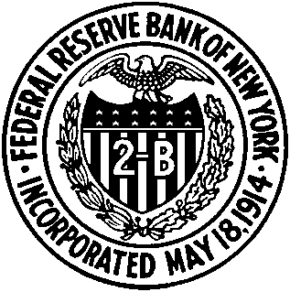

REGISTRATION FORM

New York Area Workshop on Monetary Policy

November 7, 2008

Federal Reserve Bank of New York

33 Liberty Street, New York, NY 10045
13th floor, Board Room

Name: __________________________________________________________

Affiliation: ___________________________________________________________

Address: ___________________________________________________________

E-mail/Phone/Fax: ___________________________________________________________

Please return the completed form to Betsy Turner by October 30.
Fax: 212.720.1291
Email: betsy.turner@ny.frb.org

